Estimated effect of decriminalization on opioid overdose mortality rates in Oregon, USA

  - Supplementary file
Figure S1 plots observed mortality rates along with predicted mortality rates for Oregon, comparing an intervention assumed to start in December 2019 with an intervention assumed to start in February 2021.
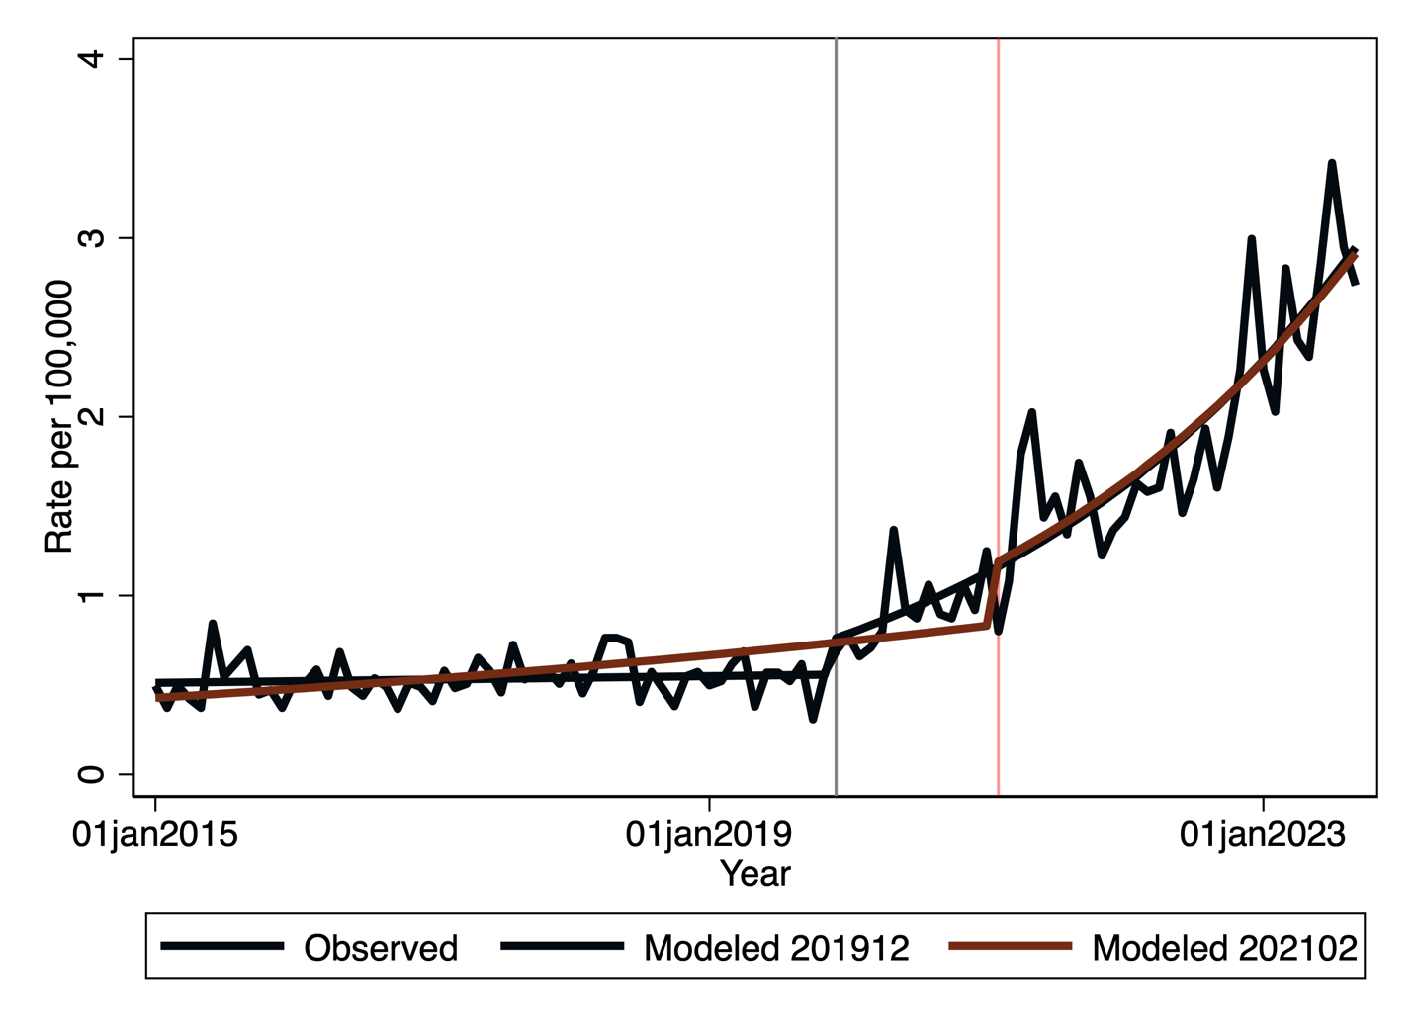
Supplementary figure S1: Comparison of regression fits for a model starting at the optimum breakpoint (December 2019) and at the point of decriminalization (February 2021)

Supplementary Figure S2 shows the fitted trend in California with the predicted values from a model with change in trend and level at the best-fitting intervention time point (March 2020). The best-fitting intervention time point is depicted by the vertical grey line, while the point of Oregon’s decriminalization of opioid use (February 2021) is shown by a vertical red line.
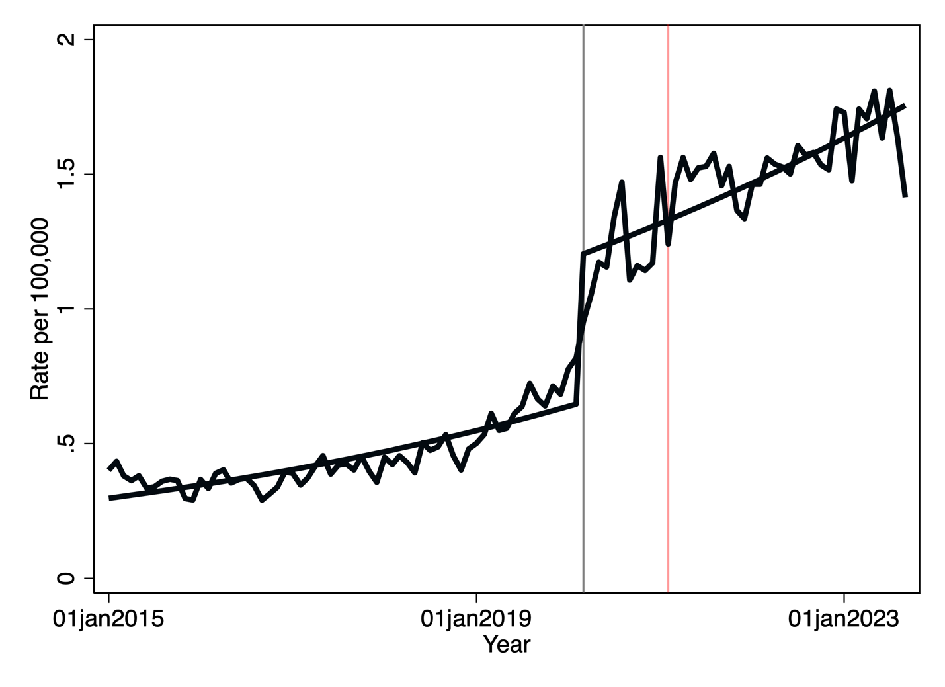
Supplementary Figure S2: Observed and predicted overdose mortality rates in California, 2015 – 2023, with best-fitting intervention point (grey line) and Oregon’s decriminalization of opioid use (red line)

Supplementary Figure S3 shows the fitted trend in Washington with the predicted values from a model with change in trend and level at the best-fitting intervention time point (March 2020). The best-fitting intervention time point is depicted by the vertical grey line, while the point of Oregon’s decriminalization of opioid use (February 2021) is shown by a vertical red line.
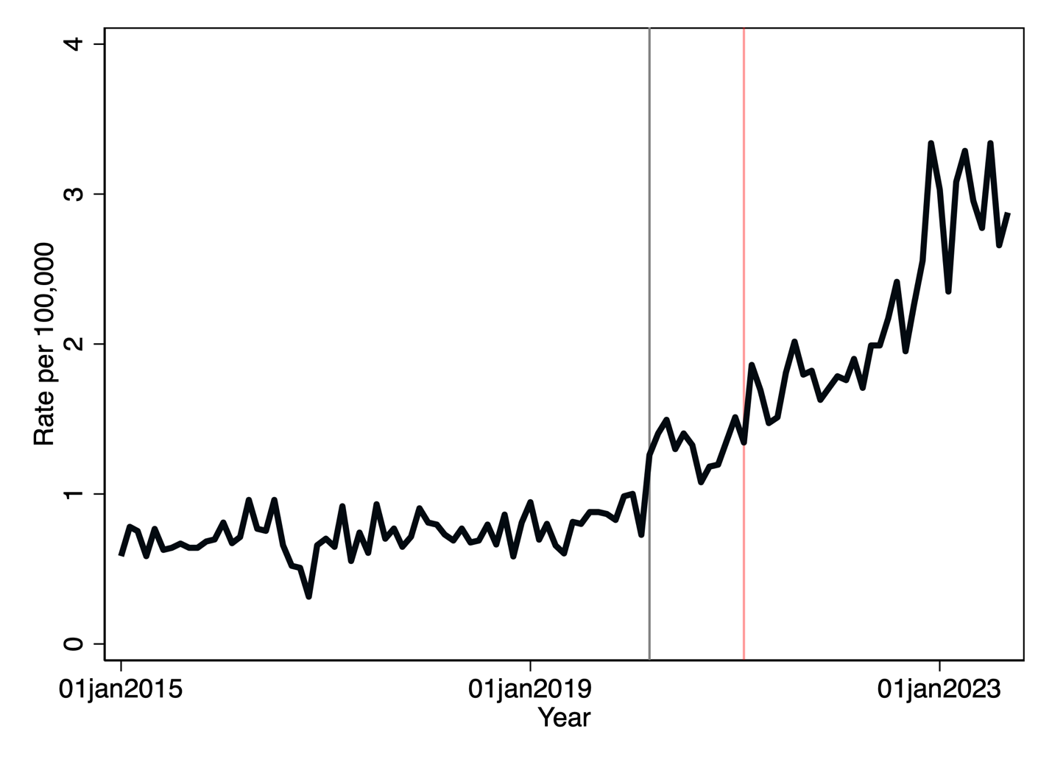
Supplementary Figure S3: Observed and predicted overdose mortality rates in Washington, 2015 – 2023, with best-fitting intervention point (grey line) and Oregon’s decriminalization of opioid use (red line)

Supplementary Figure S4 shows the fitted trend in Nevada with the predicted values from a model with change in trend and level at the best-fitting intervention time point (April 2020). The best-fitting intervention time point is depicted by the vertical grey line, while the point of Oregon’s decriminalization of opioid use (February 2021) is shown by a vertical red line.

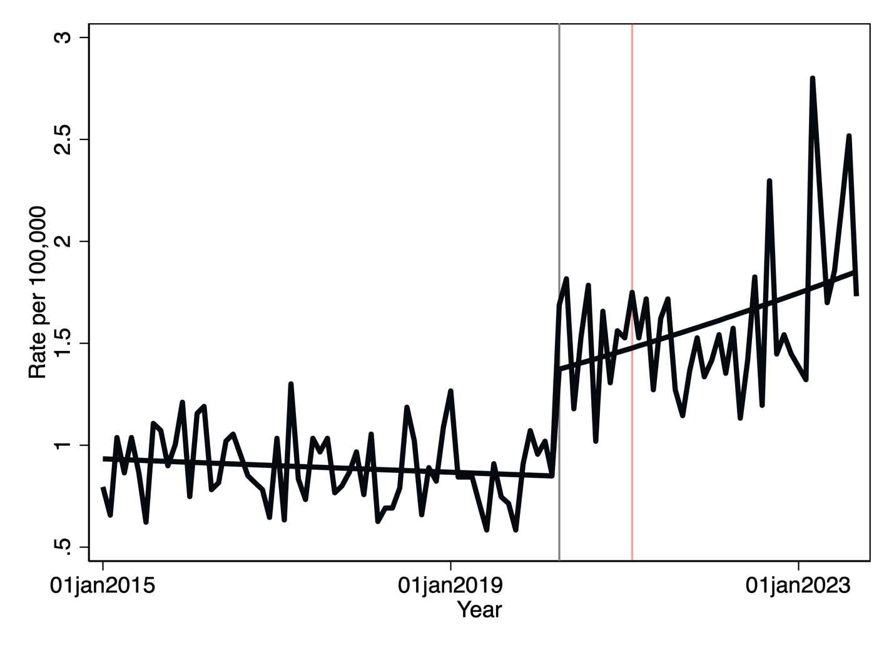
Supplementary Figure S4: Observed and predicted overdose mortality rates in Nevada, 2015 – 2023, with best-fitting intervention point (grey line) and Oregon’s decriminalization of opioid use (red line)

Supplementary Figure S5 shows the fitted trend in Idaho with the predicted values from a model with change in trend and level at the best-fitting intervention time point (April 2021). The best-fitting intervention time point is depicted by the vertical grey line, while the point of Oregon’s decriminalization of opioid use (February 2021) is shown by a vertical red line.
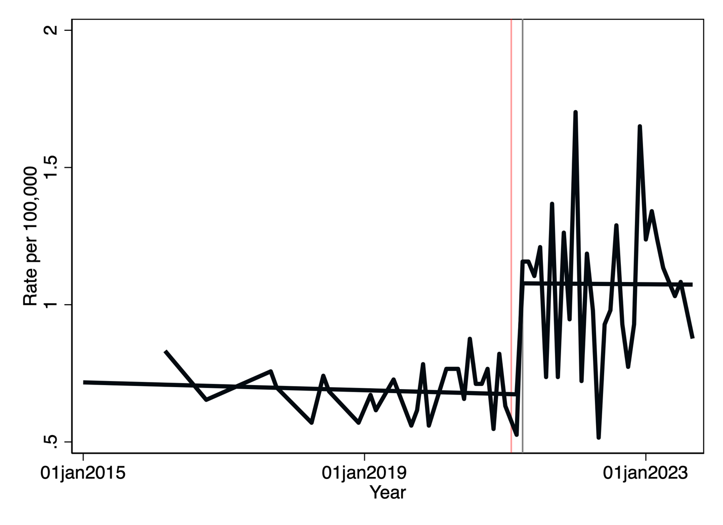
Supplementary Figure S5: Observed and predicted overdose mortality rates in Idaho, 2015 – 2023, with best-fitting intervention point (grey line) and Oregon’s decriminalization of opioid use (red line)

Supplementary Table S1 shows the joinpoint regression results for the states in which the regression model could be applied (all states except Idaho). The best-fitting models found four segments for California and Nevada, and two for Oregon and Washington.
Supplementary Table S1: Joinpoint regression results for four states
State | Start | End | Monthly Percentage change (MPC) | 95% CI | P-value
California | Jan 2015 | Sep 2016 | -0.65 | -3.10 – 0.30 | 0.2
 | Sep 2016 | Oct 2019 | 1.70 | 1.30 – 2.35 | <0.001
 | Oct 2019 | Jul 2020 | 8.52 | 6.39 – 15.20 | 0.001
 | Jul 2020 | Sep 2023 | 0.72 | 0.51 – 0.91 | <0.001
Nevada | Jan 2015 | Jan 2020 | -0.20 | -0.64 – 0.20 | 0.2
 | Jan 2020 | Apr 2020 | 22.14 | -1.66 – 30.82 | 0.08
 | Apr 2020 | May 2022 | -0.31 | -11.94 – 16.36 | 0.4
 | May 2022 | Sep 2023 | 2.81 | 0.81 – 9.69 | 0.007
Oregon | Jan 2015 | May 2019 | 0.27 | -0.28 – 0.76 | 0.3
 | May 2019 | Sep 2023 | 3.21 | 2.93 – 3.60 | <0.001
Washington | Jan 2015 | Feb 2019 | 0.25 | -0.23 – 0.63 | 0.3
 | Feb 2019 | Sep 2023 | 2.66 | 2.45 – 2.93 | <0.001

Supplementary figure S6 shows the trends fitted to data for California.
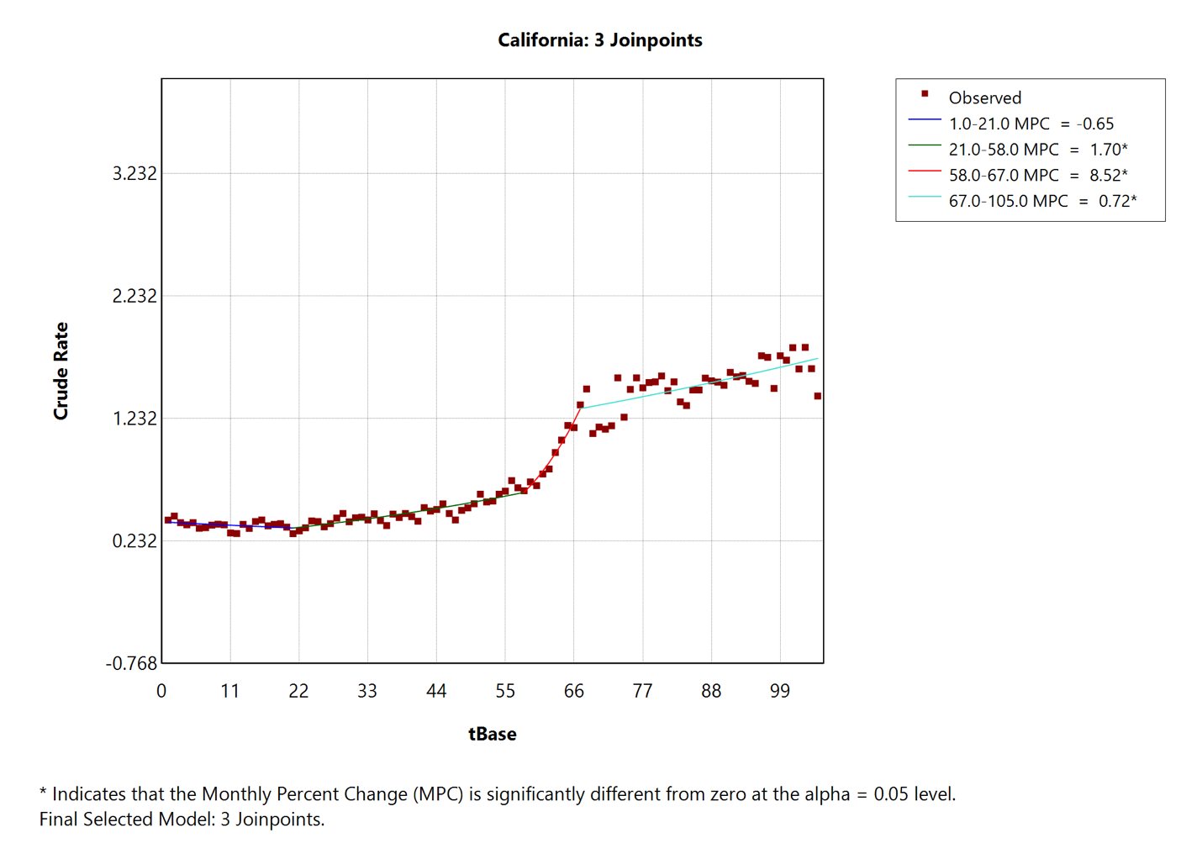
Supplementary figure S6: Best fitting joinpoint regression model for California
Supplementary figure S7 shows the best-fitting joinpoint model for Nevada, with four segments.
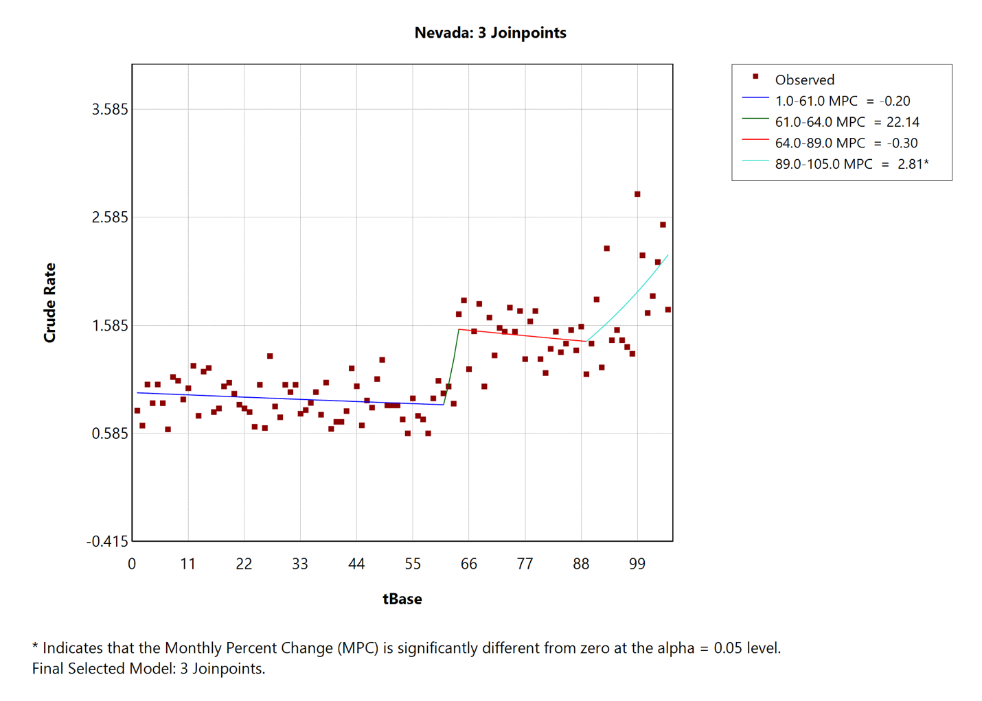
Supplementary Figure S7: Best-fitting Joinpoint regression model for Nevada
Supplementary figure S8 shows the best-fitting joinpoint regression model for Oregon, with a single break point and two segments. This is very similar to the best-fitting model from the likelihood-based method, though the rising trend starts a few months earlier.
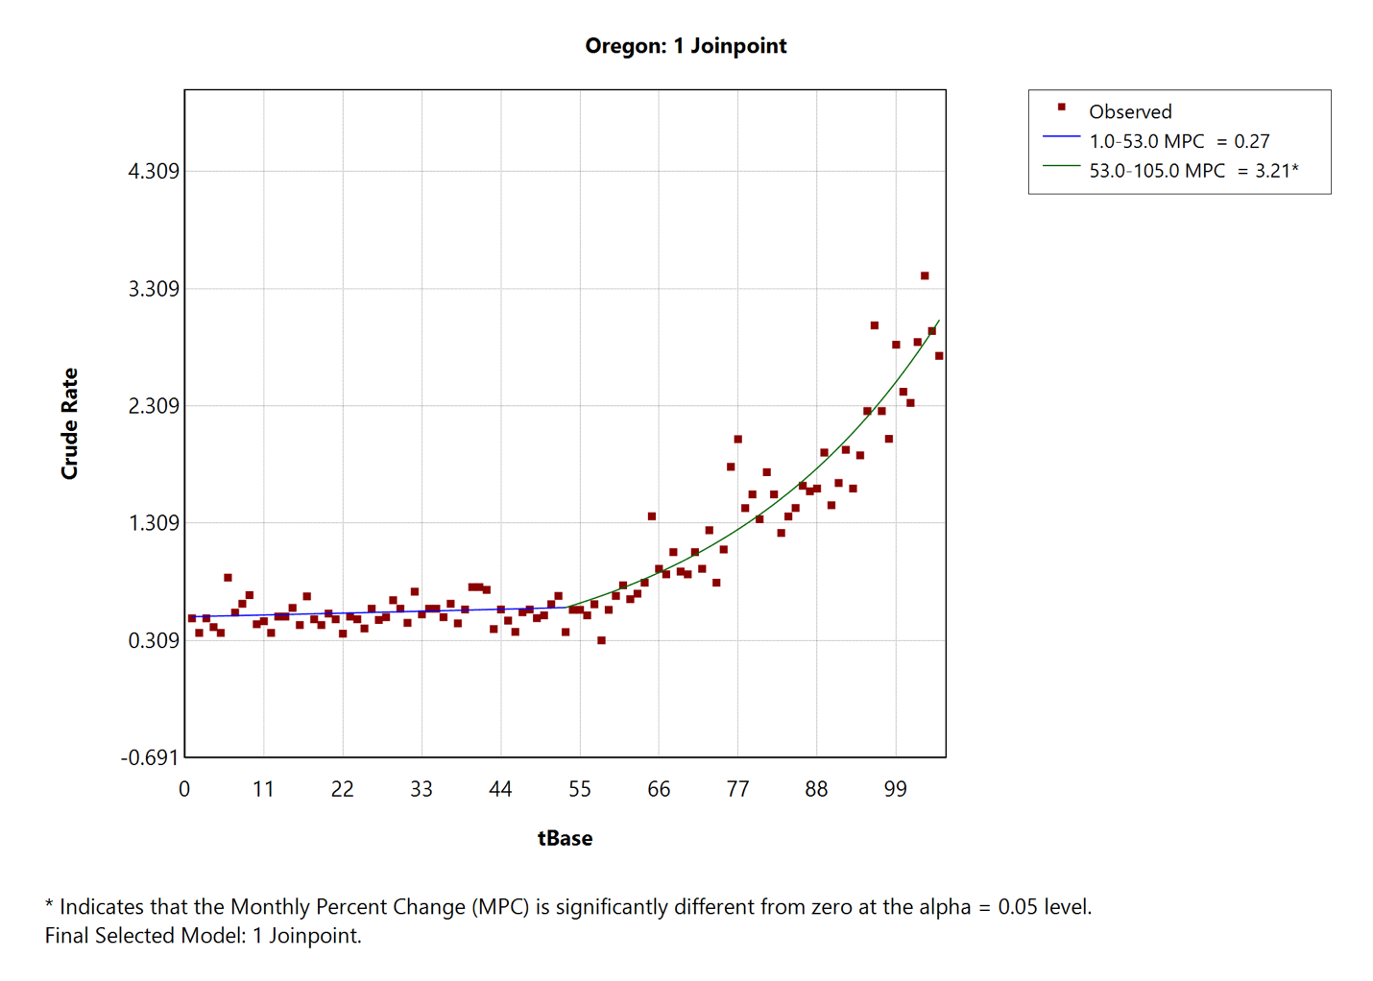
Supplementary Figure S8: Best-fitting joinpoint regression model for Oregon
Supplementary figure S9 shows the best-fitting joinpoint regression model for Washington, which is very similar to that for Oregon.
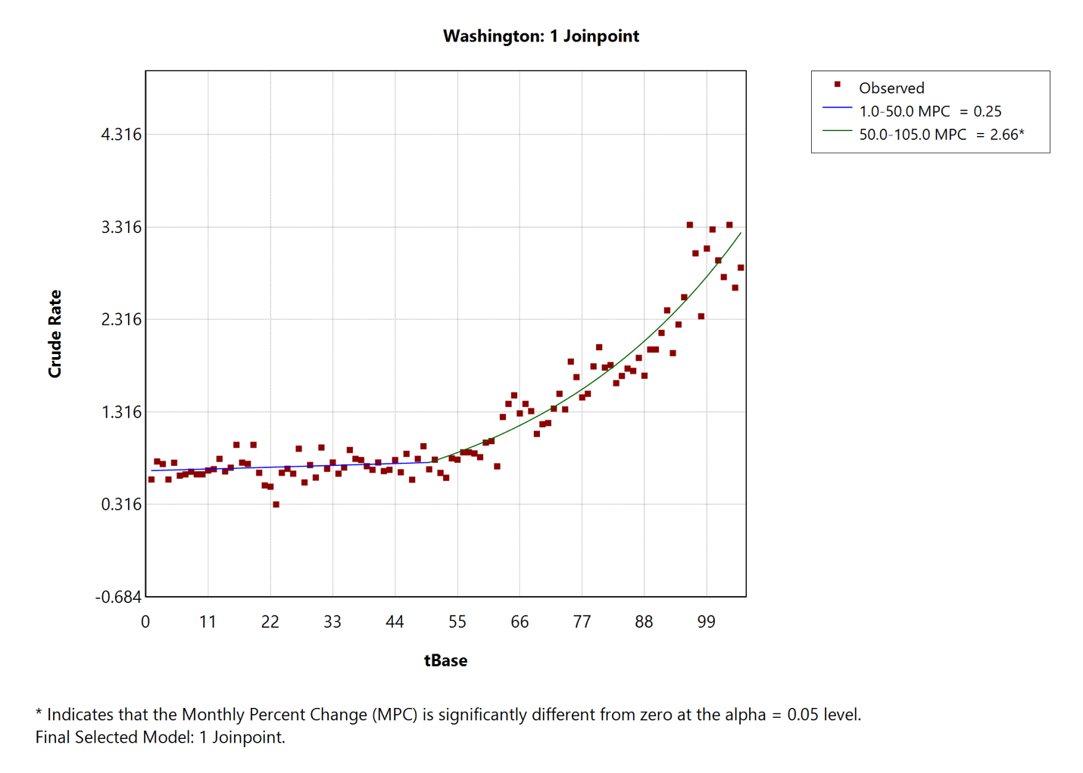
Supplementary Figure S9: Best-fitting joinpoint regression model for Washington

Supplementary Figure S10 shows the mortality trends in Oregon and its neighbours. The point when opioid use was decriminalized (February 2021) is marked with a vertical grey line.
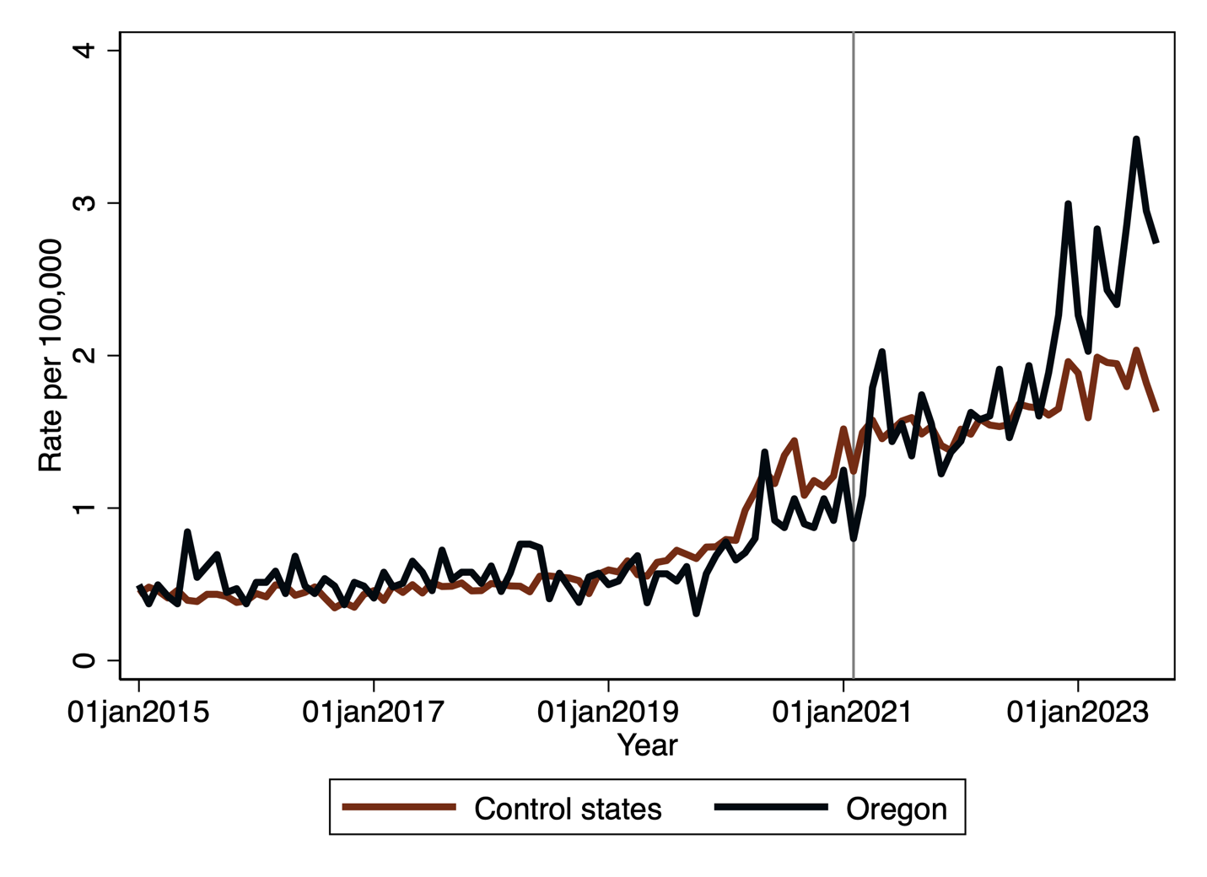
Supplementary Figure S10: Trend in opioid overdose mortality rates in Oregon and its neighboring states, January 2015 – September 2023

Supplementary table S2 shows the changes in levels and the pre- and post-decriminalization trends in Oregon and its neighbouring states, obtained by estimating linear combinations of coefficients from the difference-in-difference model in Table 2 of the main text.
Supplementary table S2: Effect of decriminalization on mortality rates in Oregon and its neighboring states, and pre- and post-decriminalization trends
State | Change in level on February 2021 | Pre-Decriminalization trend | Post-decriminalization trend
Neighboring states | 1.27 (1.22 – 1.31) | 1.018  (1.017 – 1.019) | 1.010  (1.009 – 1.011)
Oregon | 1.42 (1.26 – 1.60) | 1.009  (1.007 – 1.011) | 1.029  (1.025 – 1.034)

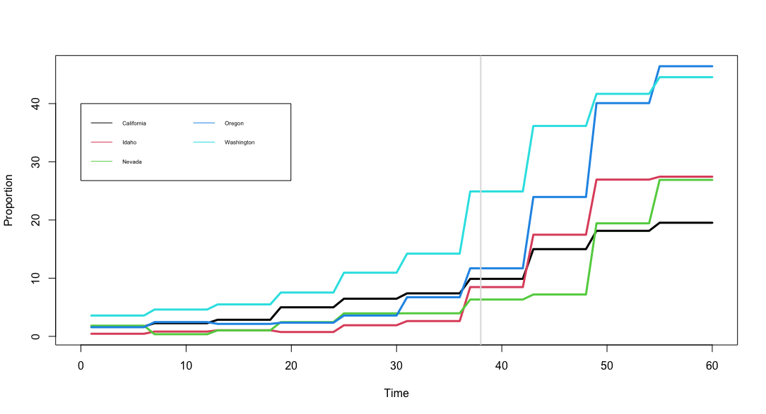

Supplementary Figure S11: Fentanyl seizure trends in the Pacific northwest, Jan 2018 – Dec 2022. Data Source: Replication package for Zoorob et al, 2024.

